**SchulPhysik_App HTML5**

The App was created as a blank project in **Evo Things Studio 2.2.0**, to run the app in the Cell phone or tablet, we need to install the following App:

For Android: Evothings Studio Viewer

For iPhone: CGTek viewer

For Windows phone: Windows phone is not used, because There is no App that works with Evo Things Studio

**Runing the HTML5 from evothigs Studio:**

First we need to connect the App installed in our phone with EvoThings that is installed in the computer, fort hat we need to go in evothings to the „Connect Tab“ and create a new Key by pressing the „GET KEY“ button, like it is shown in the image below:

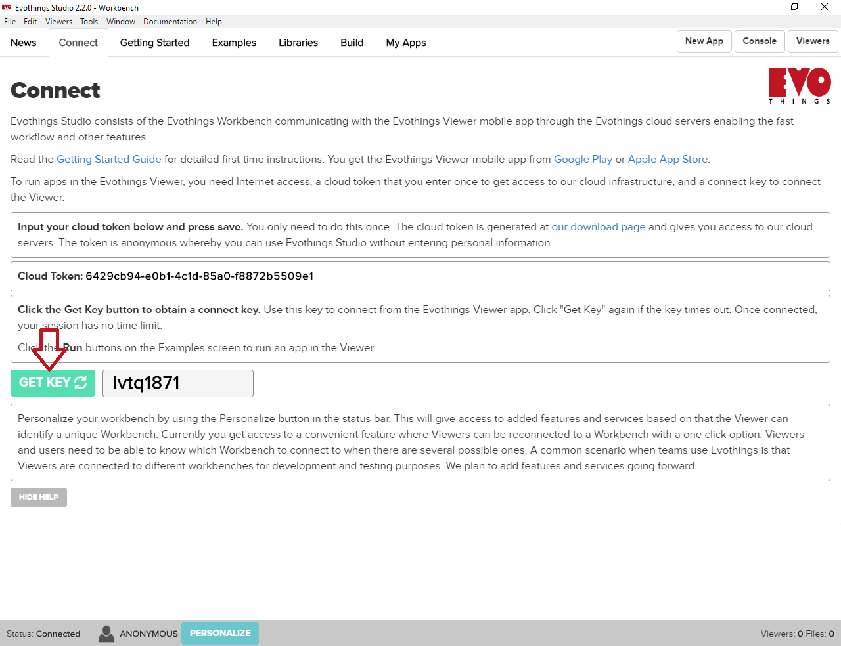

Then, this key should be written in the cell phone:

Android:

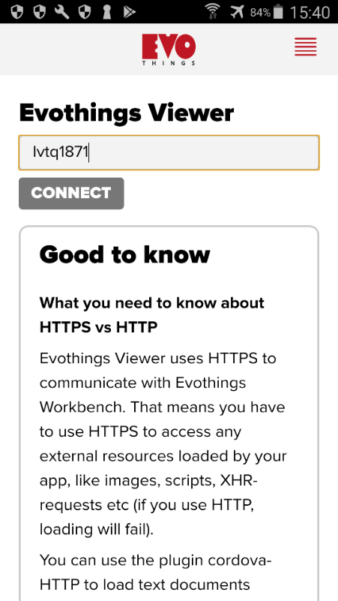

Iphone:

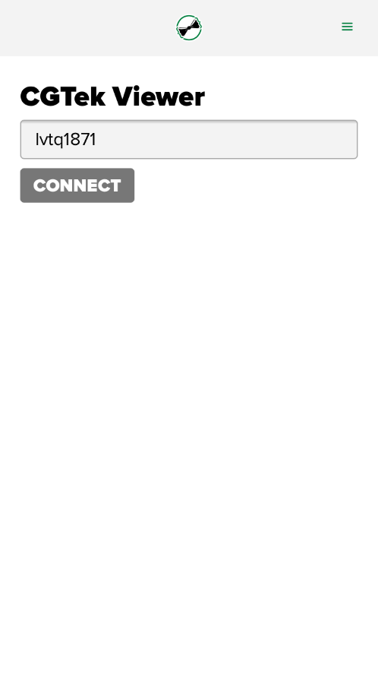

When the connection is already done, the App could be run in Evothings, by pressing the run button (In the Tab „My Apps“) that is located next to the name of the App that we would like to run, like it is shown in the image below:

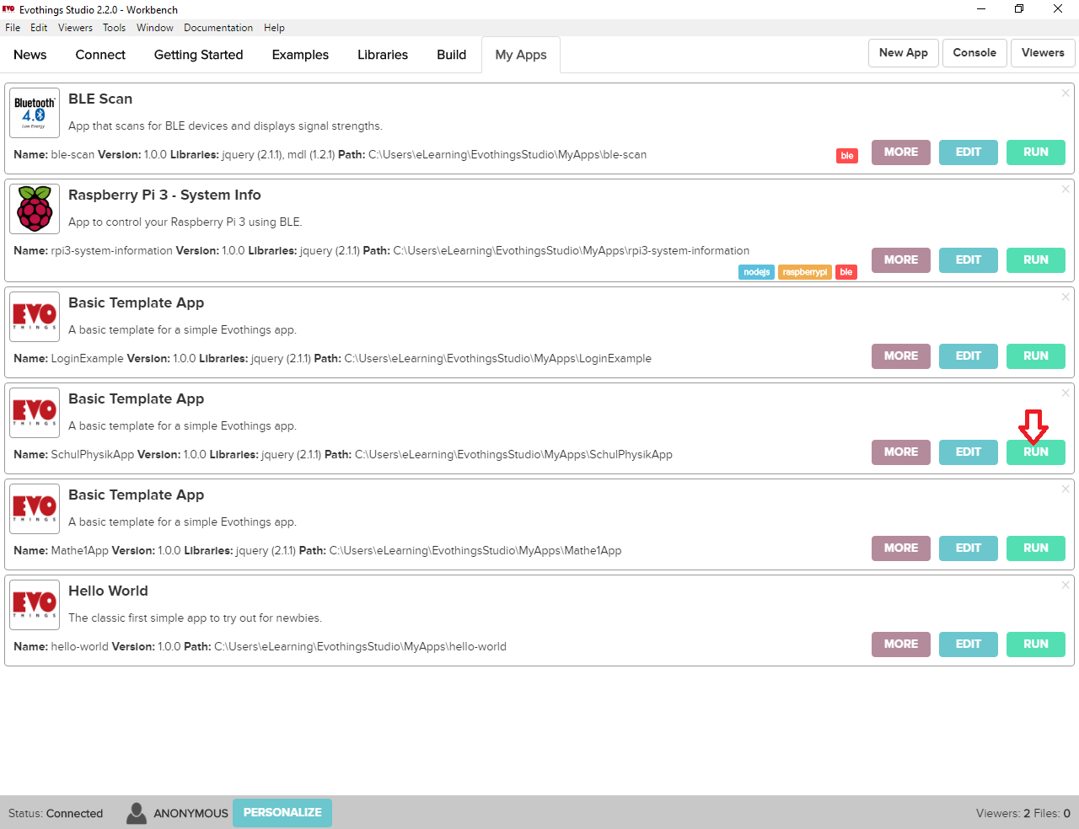

Result in each oft he devices:

Android:

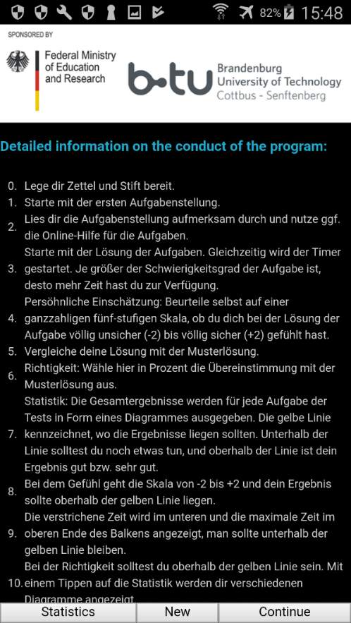

Iphone:

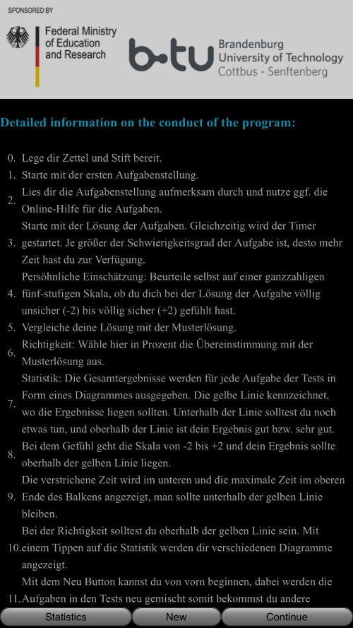

Important, the password to enter in the iphone is: 123456

